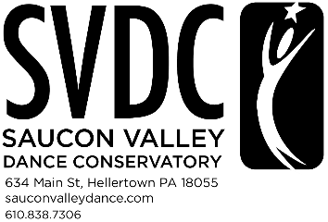

Birthday Party Waiver

Child’s Name : ______________________________________________________________________________

Parent’s Name: ______________________________________________________________________________

Phone Number: ____________________________ Email: ________________________________

Age: _________________ DOB: ______________________________________

I hereby consent to my child’s participating in an activity at Saucon Valley Dance Conservatory (SVDC). I do hereby agree to indemnify and save harmless SVDC, its owner, instructors, members, and authorized guests, as well as its agents and employees, of and from any liability of any nature or kind whatsoever arising out of or in any way connected with any claims or demands made by or on behalf of the participant. I further acknowledge that SVDC has put in place preventative measures to reduce the spread of the Coronavirus/COVID-19.
I further acknowledge that SVDC cannot guarantee that I will not become infected with the Coronavirus/Covid-19. I understand that the risk of becoming exposed to and/or infected by the Coronavirus/COVID-19 may result from the actions, omissions, or negligence of myself and others, including, but not limited to, staff, and other customers and their families.

I have read and understand the terms of this consent and indemnification as set out above.

___________________________________________________________ _______________
Parent Signature Date

